**Meyers Briggs test**

**Jeremy – INFJ (Introverted, iNtuitive, Feeling, Judging)**

**Daria – INFP (Introverted, iNtuitive, Feeling, Perceiving)**

**Brian – ENFP (Extraverted, iNtuitive, Feeling, Perceiving)**

**Shane – ESTJ (Extraverted, Sensing, Thinking, Judging)**

|  |  |  |
| --- | --- | --- |
| **The description of Personality Types:** | | |
| **INFJ**  **(The Advisor)**  People with an INFJ personality type tend to be determined, reserved, and altruistic in their behavior. They are idealists and are passionate about making the world a better place. They enjoy close relationships with a few people, but usually prefer working alone. |  | **INFP**  **(The Empath)**  People with an INFP personality type tend to be reserved, idealistic, and adaptable in their behavior. They are curious people, often lost in thought. They enjoy being by themselves or with small groups of people, and prefer to listen to and contemplate the thoughts of those around them. |
| **ENFP**  **(The Encourager)**  People with an ENFP personality type tend to be energetic, adaptable, and inventive in their behavior. They like to think up new, creative ideas and love sharing them with other people. They thrive in group settings and enjoy meeting new people. | | **ESTJ**  **(The Commander)**  People with an ESTJ personality type tend to be organized, loyal, and hard-working in their behavior. They are good, law-abiding citizens with a desire to lead. They are very principled and thrive when they are helping and encouraging others to follow a set of beliefs and values. |

**Cognitive functions:**

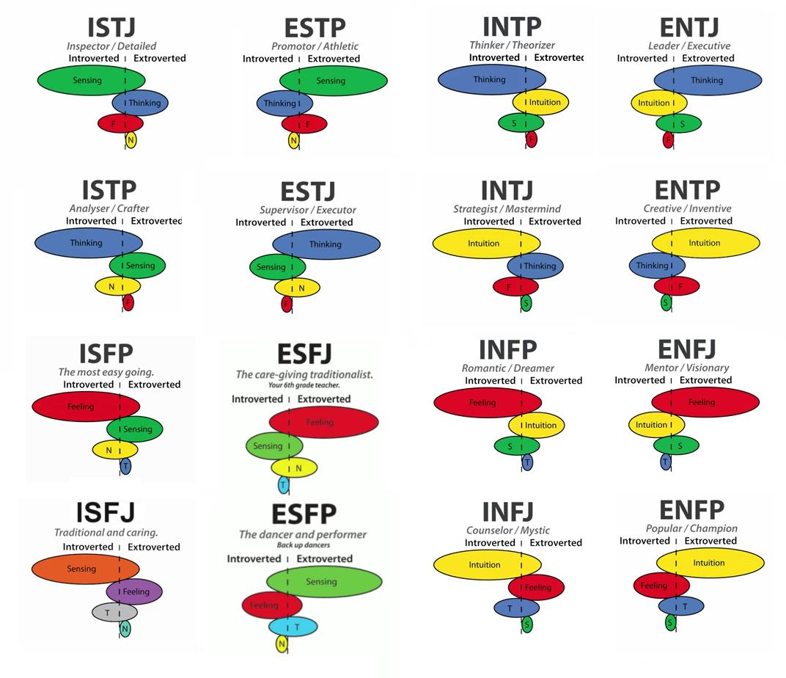

ESTJ – Shane

ENFP – Brian

INFJ – Jeremy

INFP – Daria

P

I

NF

E

J

ST

This diagram clearly shows how the personality traits of all group members intersect. Everyone got different test results, which means that we are of different personality types. For example, Shane and Daria have opposite results, so it is very important for them to learn to (?) understand each other's way of thinking and working. Jeremy and Brian, on the other hand, both have two similar letters - N(iNtuitive) and F(Feeling). They have some analogous traits such as tendency to process emotionally and focus their attention on the bigger picture. However, Jeremy is I(Introverted) and J(Judging) type, while Brian is E(Extroverted), P(Perceiving) type so they need to find an approach to each other's features.

|  |
| --- |
| **How can these types communicate effectively with each other?** |
| **INFJ&INFP (Jeremy, Daria):**  INFPs and INFJs are tend to prefer time alone, process emotionally, and focus their attention on the bigger picture. However, INFPs are generally more flexible in their plans, while INFJs tend to follow schedules and processes. INFPs should be consistent around INFJs, while INFJs should give INFPs the freedom to move at their own pace. |
| **INFJ&ENFP (Jeremy, Brian):**  INFJs and ENFPs are both tend to process emotionally and focus their attention on the bigger picture. However, INFJs tend to follow schedules and prefer to spend time alone or in small groups, while ENFPs are generally more flexible in their plans and thrive in larger group settings. INFJs should work to build personal connections with ENFPs, while ENFPs should allow INFJs space to recharge by communicating via email when necessary. |
| **INFJ&ESTJ (Jeremy, Shane):**  INFJs and ESTJs are very different; though they both prefer to follow a plan, INFJs are reserved, empathetic, and creative, while ESTJs are outgoing, logical, and present-focused. INFJs should work on expressing themselves more rationally around ESTJs. ESTJs should listen to and show empathy toward INFJs, allowing them space to be alone, when needed. |
| **INFP&ENFP (Daria, Brian):**  INFP and ENFP personalities both tend to focus on the overall perspective, consider the feelings of themselves and others, and prefer to follow flexible schedules. However, INFPs tend to be more reserved and ENFPs are generally outgoing. INFPs should feel open to share their feelings with ENFPs while ENFPs should respect INFPs desire to spend time alone. |
| **INFP&ESTJ (Daria, Shane):**  INFPs are generally emotionally intuitive, reserved, creative, and adaptable, while ESTJs are outgoing, rational, present-focused, and organized. INFPs should be direct and honest when addressing ESTJs. ESTJs should be encouraging around INFPs, allowing them space to be alone. |
| **ENFP&ESTJ (Brian, Shane):**  ENFPs are generally emotionally intuitive, creative, and adaptable, while ESTJs are rational, present-focused, and organized. ENFPs should be direct and honest when addressing ESTJs. ESTJs should encourage ENFPs by avoiding overt criticism. |

|  |
| --- |
| **How can these types build trust?** |
| **INFJ&INFP (Jeremy, Daria):**  INFPs are more likely to trust INFJs who allow freedom to follow a loose schedule, while INFJs tend to trust INFPs who follow through on set commitments. |
| **INFJ&ENFP (Jeremy, Brian):**  INFJs tend to trust ENFPs who follow through on set commitments, while ENFPs are more likely to trust INFJs who allow them the freedom to follow a loose schedule. |
| **INFJ&ESTJ (Jeremy, Shane):**  INFJs are likely to trust ESTJs who show concern for INFJs’ feelings. INFJs need to feel safe and connected to build lasting relationships.  ESTJs will grow to trust INFJs who can be more direct and level-headed; INFJs should also allow ESTJs the independence they need to thrive. |
| **INFP&ENFP (Daria, Brian):**  INFPs are more likely to trust ENFPs who listen to and affirm INFPs’ ideas.  ENFPs tend to trust INFPs who are open, caring, and seek to create personal connections with them. |
| **INFP&ESTJ (Daria, Shane):**  INFPs are more likely to trust ESTJs who appreciate their creative ideas and allow them to follow a flexible schedule; ESTJs should be attentive to the needs of INFPs.  ESTJs tend to trust INFPs who share their thoughts openly and avoid strong emotional reactions; INFPs should also recognize and appreciate ESTJs’ practical thinking. |
| **ENFP&ESTJ (Brian, Shane):**  ENFPs are more likely to trust ESTJs who are supportive and allow ENFPs to follow a flexible schedule, while ESTJs tend to trust ENFPs who communicate openly and avoid strong emotional reactions. |

|  |
| --- |
| **How can these types resolve conflicts?** |
| **INFJ&INFP (Jeremy, Daria):**  Since INFPs and INFJs are both Feeling personalities, they should each focus on expressing how a situation affects them emotionally, while showing empathy to the other person. Though both INFPs and INFJs dislike confrontation, conflict should be addressed in a timely manner. To avoid stress, INFPs and INFJs should both be open about their perspectives and take space to reflect. |
| **INFJ&ENFP (Jeremy, Brian):**  Since INFJs and ENFPs are both Feeling personalities, they should each focus on expressing the emotional impact of a situation, while remaining empathetic to one another. To avoid stress, INFJs and ENFPs should both be open about their perspectives and ENFPs should encourage INFJs to take space to reflect, if needed. |
| **INFJ&ESTJ (Jeremy, Shane):**  ESTJs should give INFJs the space and support they need to feel safe to express themselves. INFJs need to be direct and logical when addressing a problem with ESTJs; they should allow ESTJs to work through each problem individually. |
| **INFP&ENFP (Daria, Brian):**  Since INFPs and ENFPs are both Feeling personalities, they should focus on communicating how they feel, while remaining calm and empathetic. To avoid a stressful confrontation, INFPs should be more vocal about their perspective, while ENFPs should avoid overcrowding INFPs, allowing them to take space to reflect. |
| **INFP&ESTJ (Daria, Shane):**  INFPs tend to express themselves emotionally, while ESTJs prefer to work through issues logically. INFPs should be open about their perspective with ESTJs, avoiding the use of overly emotional phrasing and allowing ESTJs to sort through each issue individually. ESTJs should focus on listening to INFPs and communicating their side calmly. |
| **ENFP&ESTJ (Brian, Shane):**  ENFPs tend to express themselves emotionally, while ESTJs prefer to work through issues logically. ENFPs should address issues directly with ESTJs, avoiding the use of overly emotional phrasing and allowing ESTJs to sort through situations individually. ESTJs should focus on listening to ENFPs without interrupting and communicating their side in a calm, patient tone. |

|  |
| --- |
| **How can these types work together?** |
| **INFJ&INFP (Jeremy, Daria):**  Both INFPs and INFJs bring creative solutions and empathy to a workplace; however, INFPs also offer a flexible attitude, while INFJs offer commitment and dedication. INFPs can help INFJs learn to adapt to unexpected situations, while INFJs can help INFPs achieve their personal goals. |
| **INFJ&ENFP (Jeremy, Brian):**  Both INFJs and ENFPs bring creative solutions and empathy to a workplace; however, INFJs also offer commitment and dedication, while ENFPs offer a flexible attitude. INFJs can help ENFPs achieve their professional goals. ENFPs can help INFJs step outside of their comfort zone and try new things. |
| **INFJ&ESTJ (Jeremy, Shane):**  INFJs bring creative ideas and considerate solutions to a work environment. They can help ESTJs consider how their decisions will impact others.  ESTJs offer attentiveness and practical thinking. They can help INFJs share their thoughts more openly with others. |
| **INFP&ENFP (Daria, Brian):**  Both INFPs and ENFPs bring caring, creative thinking and adaptability to a work environment. However, INFPs are also strong, independent workers, while ENFPs are social and inviting. INFPs can help ENFPs become better listeners, while ENFPs can help INFPs express themselves more directly. |
| **INFP&ESTJ (Daria, Shane):**  INFPs bring innovative solutions and empathetic reasoning to a work environment, while ESTJs offer attention to detail and goal-oriented planning. INFPs can help ESTJs consider others when making decisions, while ESTJs can help INFPs follow through on accomplishing personal or professional goals. |
| **ENFP&ESTJ (Brian, Shane):**  ENFPs bring innovative solutions, empathetic reasoning, and adaptability to a work environment, while ESTJs offer attention to detail, logical decision-making, and goal-oriented planning. ENFPs can help ESTJs consider others when making decisions, while ESTJs can help ENFPs achieve personal and professional goals. |

|  |
| --- |
| **How can these types deal with change?** |
| **INFJ&INFP (Jeremy, Daria):**  Due to their Perceiving trait, INFPs tend to be naturally accepting of new situations. INFJs, however, may have a more difficult time, since they tend to follow set plans. INFPs should help INFJs focus on the positive aspects of change and create a new plan or routine. |
| **INFJ&ENFP (Jeremy, Brian):**  Due to their Perceiving trait, ENFPs tend to be naturally accepting of new situations. INFJs may have a more difficult time since they tend to prefer consistency. ENFPs should help INFJs focus on the positive aspects of change and create a new plan or routine. |
| **INFJ&ESTJ (Jeremy, Shane):**  Because they tend to follow set plans, INFJs and ESTJs may have a difficult time adapting to change. They should consider the positive aspects of a new situation and be willing to modify their plans. |
| **INFP&ENFP (Daria, Brian):**  Due to their Perceiving trait, INFPs and ENFPs tend to be naturally accepting of new situations. They are adaptable personalities who tend to crave unexpected experiences and appreciate positive change. |
| **INFP&ESTJ (Daria, Shane):**  Due to their Judging trait, ESTJs tend to have a difficult time adapting to a new situation. INFPs, however, usually have a flexible attitude and adjust well to change. INFPs should help ESTJs consider the positive aspects of change and create a new plan to achieve their goals. |
| **ENFP&ESTJ (Brian, Shane):**  Because they tend to follow set plans, ESTJs may have a difficult time adapting to a new situation. ENFPs, however, usually have a flexible attitude and adjust well to change. ENFPs should encourage ESTJs to focus on the benefits of the situation. |

**Learning Style Tests Results**

All members of our team are visual. Visuals learn by reading or seeing pictures. They understand and remember things by sight. Visuals like to see what they are learning and often close their eyes to visualize or remember something. According to this results, each person in our group perceive information visually and this knowledge will be useful during our work on the project.

**Learning tips for visuals:**

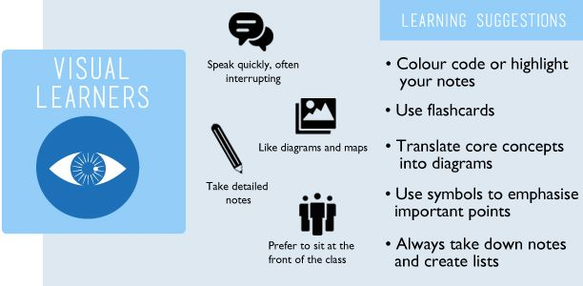

**Other tests result**

**Brian’s test result:**

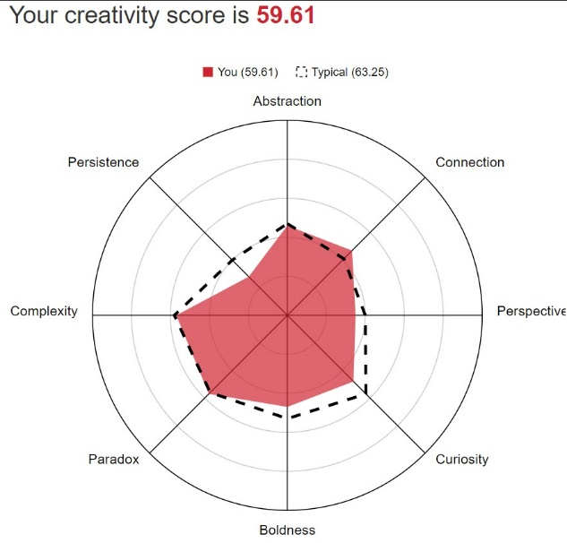

This test evaluates creativity. Working in a group on a project often requires a creative approach, so such tests can be useful in determining the strengths and weaknesses of a person. One of the strongest Brian’s creativity features is connection which means the ability to make connections between things that don't initially have an apparent connection. This feature will help to solve problems arising in the work on the project in an unusual way. (links)

**Jeremy’s test result:**

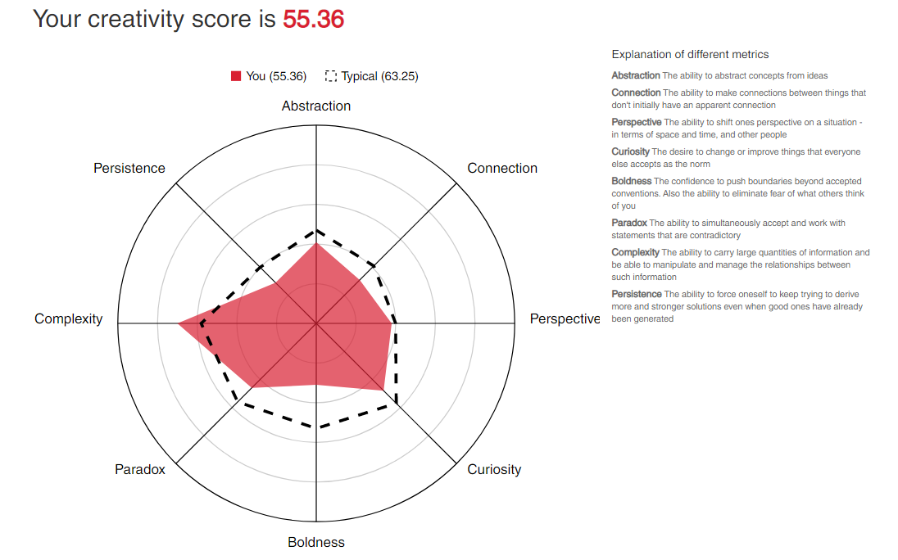

Jeremy has chosen test on creativity too. His strongest feature is complexity - the ability to carry large quantities of information and be able to manipulate and manage relationships between such information. It will be incredibly useful in working with a big amount of text and information.

**Shane’s test result:**

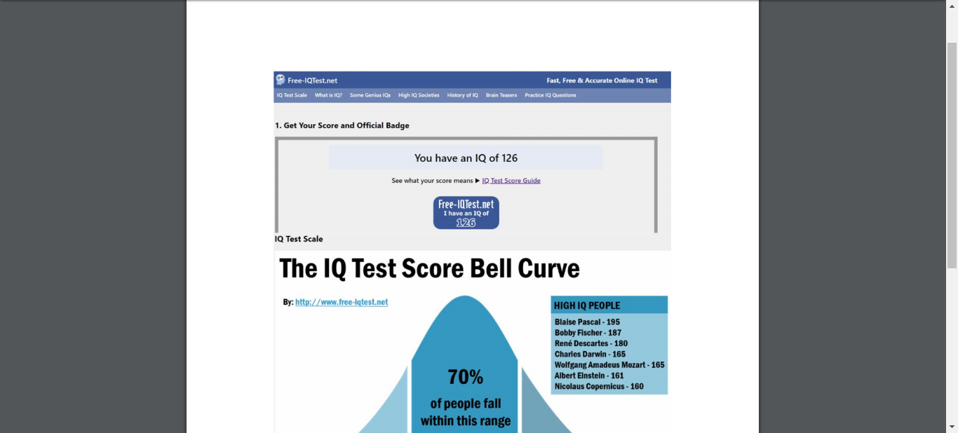

Shane has chosen IQ test. As he wrote in his Assignment 1 project, IQ test would not necessarily influence behaviour in a team environment. It would be more rational to draw conclusions based on abilities and personalities.

**Daria’s test result:**

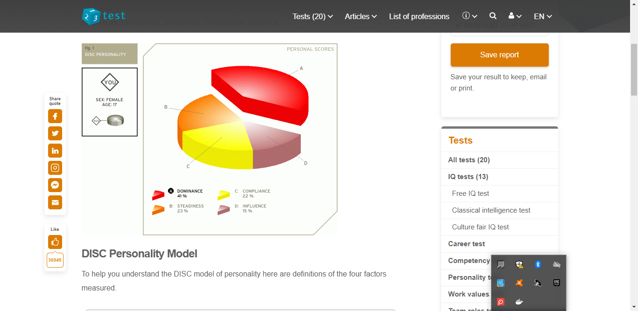

Daria has done DISC test. Her result is dominance which means that she is responsible and likes changes and challenging tasks.

**References:**

Sidoruk. Cognitive Functions [Online]. Available at: <https://www.pinterest.pt/pin/839358449275858166/>

Crystal. (2019) Personality Hub [Online]. Available at:

<https://www.crystalknows.com/personalities>

Pennsylvania Higher Education Assistance Agency. (2019) Education Planner [Online]. Available at:

<http://www.educationplanner.org/students/self-assessments/learning-styles-quiz.shtml?event=results&A=7&V=10&T=3>

Career FAQs. Unlock your learning style [Online]. Available at:

<https://www.pinterest.ru/pin/822892163146640731/>

[Online]. Available at:

<http://www.testmycreativity.com/>

Free-IQTest.net. (2020) The Free IQ Test [Online]. Available at:

<http://www.free-iqtest.net/>